Sensitivity GUI Unit Tests

Contents

Introduction 3

Summary of Tests Conducted 4

Procedure of Tests 4

Days of Backup 5

Efficiency Backup 5

Repair Factors 5

Initial Efficiency 5

Appendix 6

Bibliography 6

# Introduction

sensitivity analysis determines how values of an independent variable affect a particular dependent variable under a given set of assumptions [1]. The sensitivity analysis is conducted on inputs to the Stochastic Infrastructure Remediation Model (SIRM) namely: Repair Factors, Days Backup, Efficiency of Backup, and Initial Efficiency. Then a range is input to the Sensitivity Analysis Tool, and a sector is chosen. The Sensitivity Analysis tool conducts a sensitivity analysis on the inputs to that were discussed earlier, the output shows the optimal value for the inputs. An Example of inputs and the gui tool is shown below. 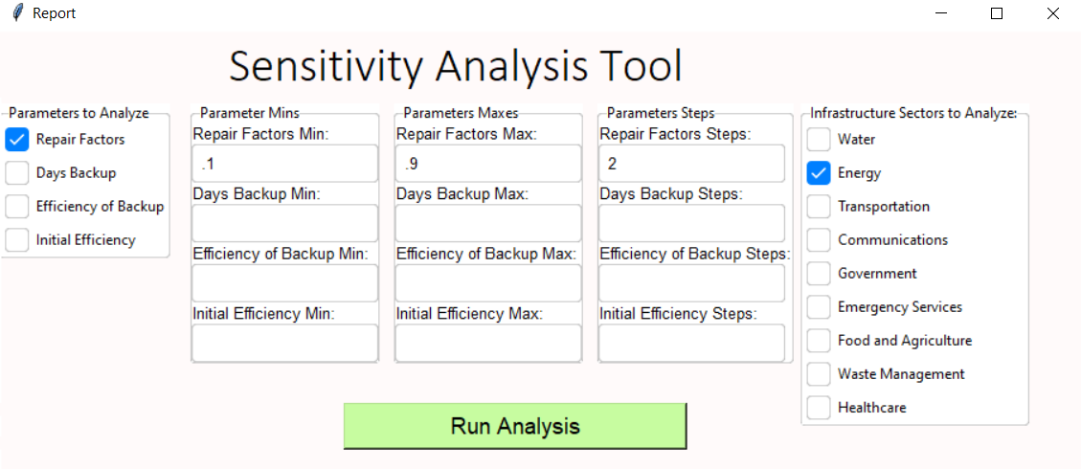

Figure 1 Example Of Sensitivity

# Summary of Tests Conducted

Table 1 Summary Of Tests



In Table 1 there is a summary of the expectations of the tests and results of the tests that where conducted, 4 tests were conducted, and all passed. All tests were done comparing the recovery times of the output of the sensitivity GUI and the infrastructures GUI.

# Procedure of Tests

All tests that have been conducted where comparing the recovery days, which were calculated by the python tool and the sensitivity tool. The procedure of the test was as follows values were entered for minimum and maximum values for the check parameters such as figure 1 and then, run the sensitivity analysis tool. Then separately Sensitivity GUI is run, and the similar scenarios were compared to see if the results where the same.

# Days of Backup

The Days of Backup is defined in the chart below:

Table 2 Backup Percentages



When testing the days of backup, the days of recovery were compared. In the scenario, the backup days were varied, and it is seen that the days of recovery matches for the given scenario. The CSV files where compared and found to be equal indicating a passed test case.

# Efficiency Backup

The Efficiency Backup is defined in the chart below:

Table 3 Efficiency Backup



When testing the Efficiency Backup, the days of recovery were compared. In the scenario, the Efficiency Backup were varied, and it is seen that the Efficiency Backup match for the given scenario. The CSV files were compared and found to be equal indicating a passed test case.

# Repair Factors

The Repair Factor is defined in the chart below:

Table 4 Repair Factors



When testing the Repair Factors, the days of recovery were compared. In the scenario, the Repair Factors were varied, and it is seen that the days of recovery matches for the given scenario. The CSV files were compared and found to be equal indicating a passed test case.

# Initial Efficiency

The Initial Efficiency is defined in the chart below:

Table 5 Initial Efficiency



When testing the Initial Efficiency, the days of recovery were compared. In the scenario, the Initial Efficiency were varied, and it is seen that the days of recovery matches for the given scenario. The CSV files were compared and found to be equal indicating a passed test case.

# Bibliography

|  |  |
| --- | --- |
| [1] | W. KENTON, "Investopedia," 28 May 2020. [Online]. Available: https://www.investopedia.com/terms/s/sensitivityanalysis.asp. |